Steps for using Arcpy in Anaconda

By: Thomas Yamashita

This tutorial is based on something I got off stackexchange. The link is below:

<https://gis.stackexchange.com/questions/119503/getting-arcpy-to-work-with-anaconda>

1. Install a 32 bit version of Anaconda: https://www.anaconda.com/distribution/
   1. This is critical to using arcpy in Anaconda
   2. Not necessary to use other python functions in ArcGIS
2. Check which version of python, numpy, and matplotlib are installed on ArcGIS
   1. >>> import sys, numpy, matplotlib
   2. >>> print(sys.version, numpy.__version__, matplotlib.__version__)
3. Create a new environment based on the version of python:
   1. EXAMPLE: conda create -n arc106 python=2.7.14
4. activate the new environment
   1. EXAMPLE: activate arc106
5. install numpy and matplotlib modules using either "conda" or "pip"
   1. EXAMPLE: conda install numpy=1.9.3
   2. EXAMPLE: pip install matplotlib==1.5.2
      1. Note: Using pip requires a == instead of a =
6. install other required modules (Same as other tutorial)
   1. TYPE: conda install pyparsing xlrd xlwt pandas scipy ipython ipython-notebook ipython-qtconsole spyder pysal
7. copy the ArcGIS path file to Anaconda (same as other tutorial)
   1. from the Python27->ArcGIS10.6->Lib->site-package
   2. to Anaconda_x86->envs->arc106->Lib->site-packages
   3. file is named something like: “Desktop10.6.pth”
8. Create a pth file in the new Anaconda environment
   1. Copy the Anaconda site-packages folder file path (see screenshot below) into a notepad file (right click on the address)
      1. File path from step 7b
   2. Save the file as a .pth file
   3. Copy this into the ArcGIS site-packages folder (same folder as in step 7a)

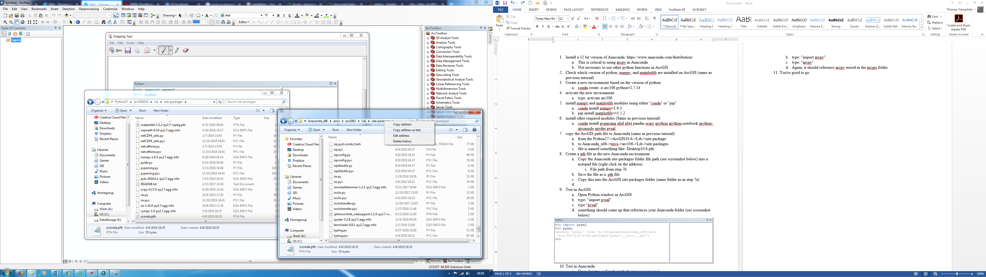

1. Test in ArcGIS
   1. Open Python window in ArcGIS
   2. TYPE: "import pysal"
   3. TYPE: "pysal"
   4. something should come up that references your Anaconda folder (see screenshot below)

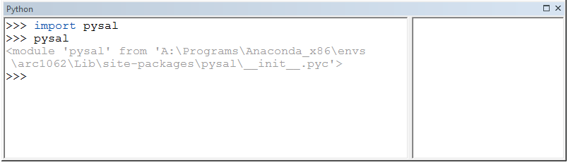

1. Test in Anaconda
   1. Open Jupyter or Spyder (which ever one you use)
   2. TYPE: "import arcpy"
   3. TYPE: "arcpy"
   4. Again, it should reference arcpy stored in the arcgis folder
2. You're good to go